420-204-RE

Final Project Proposal

NAME:

IDEA:

The Project will cover the physics of motion, The main of the app will be a game where the player must throw /launch projectiles in order to win , additionally there will be the option to play against an enemy, which could be the computer or another person using the same computer. Where each opponent will take turns to launch things at the enemy in order to destroy them.

There will also be an educational mode, where the app will show and create educational animations using the mechanics of the game which are based off of physics and math.

The main menu will present the player with these options

Main Menu example (Rough Draft):

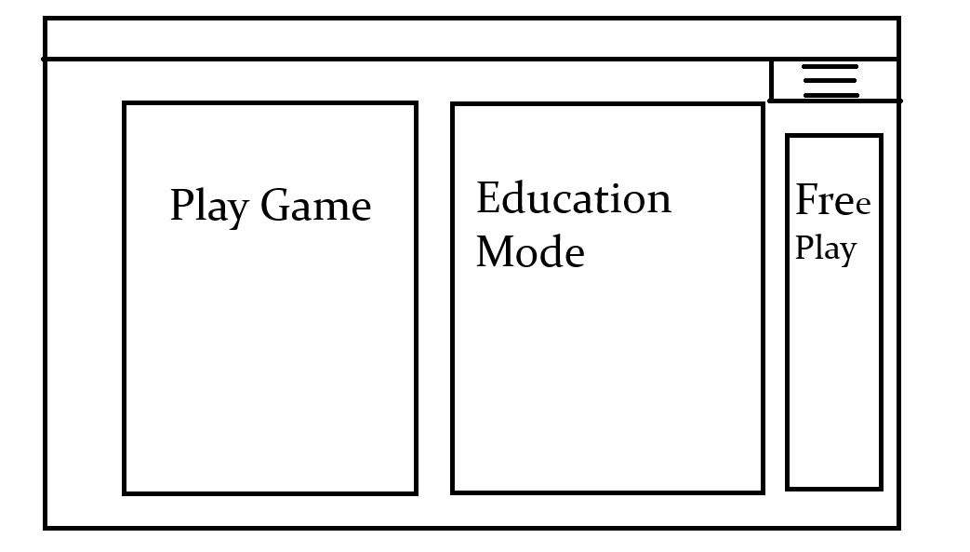

Game example (rough draft) :

Player vs environment:

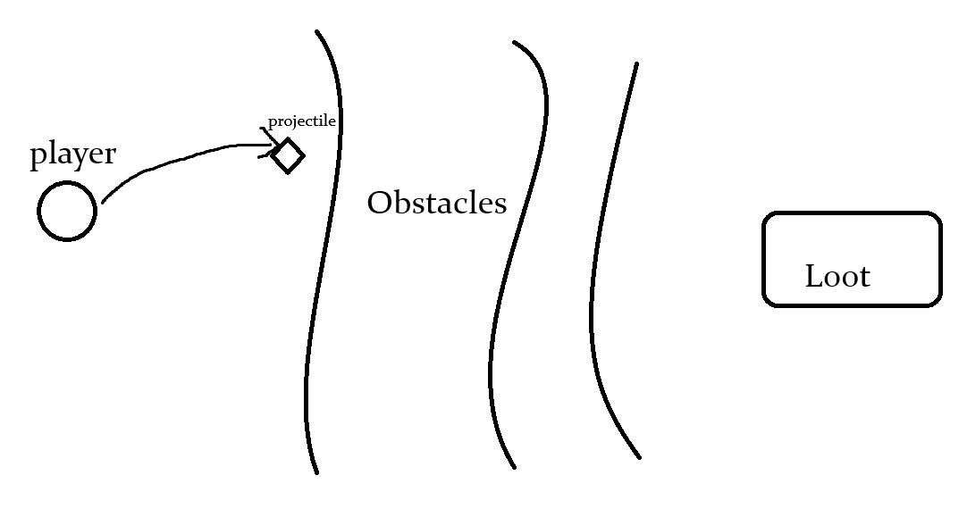

Player vs Computer:

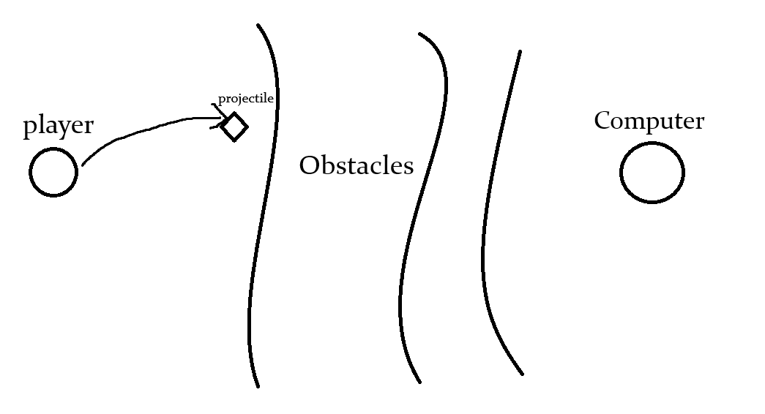

*Players turn*

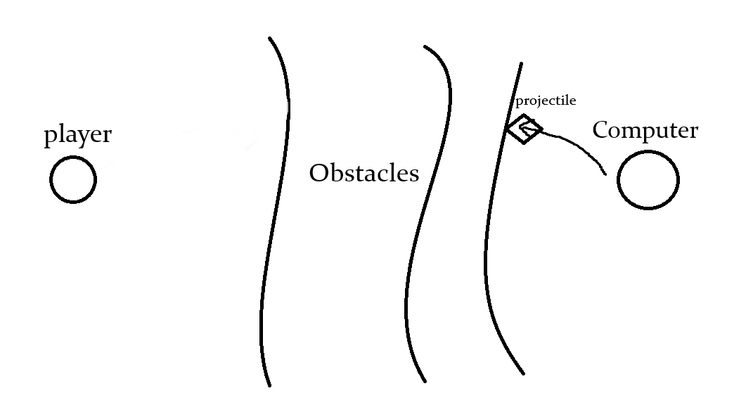

*Computers turn*

FEATURES:

The game will take place at multiple scales: Regular world scale, Astronomical scale, and everything in between:

-Layout/design features:

-Physics/Math features:

-game features:

-additional/optional features: